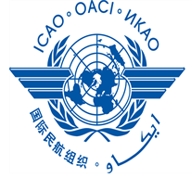 | International Civil Aviation Organization
FIFTEENTH MEETING OF THE ASIA/PACIFIC METEOROLOGICAL INFORMATION EXCHANGE WORKING GROUP
(MET/IE WG/15)
 | Bangkok, Thailand, 20 – 22 March 2017

Agenda Item xx: xxxxxxxxxxxxxxxxxxxxxxxxxxxxxxxxxxxxxxxxxxxxxxxxxxxxxxxxxxxxx
(Please select the appropriate agenda from WP/01 for the proposed WP/IP papers)

TITLE/SUBJECT
(Presented by name of States/Administration)

SUMMARY
This paper presents WRITE BRIEF OVERVIEW SUMMARY HERE, SHOULD NOT BE LONGER THAN 100 WORDS

1. INTRODUCTION

1.1 Text

2. DISCUSSION

Heading 1

2.1 Text

2.2 Text

Heading 2

2.3 Text

2.4 Text

3. ACTION REQUIRED BY THE MEETING

3.1 The meeting is invited to:

a) note the information contained in this papers; and

b) discuss any relevant matters as appropriate.

* the meeting is invited to amend action in a), b) as appropriate
_ _ _ _ _ _ _ _ _ _ _ _ _

